INVENTION DISCLOSURE FORM
Confidential & Attorney-Client Privileged

Applicant Name SR University
Applicant Address: Ananthsagar, Hasanparthy (M), Warangal Urban, Telangana - 506371,

- Particulars of Inventors

Mr./Ms/Dr. | Name (Full) | Department | Designation | Mobile No. | Email | Postal Address
Mr. | Naresh Kumar Sripada | CS&AI | Asst. Professor | 9866000203 | Naresh22.in@gmail.com | Hanamkonda
Ms. | Keerthis  sree | CS&AI | Student | 7770001019 | keerthisreerasamalla@gmail.com | Hanamkonda
Ms. | Karunya | CS&AI | Student | 8522878316 | Allamkarunya.7@gmail.com | Hanamkonda
Ms. | Varshitha | CS&AI | Student | 6303302614 | junenivarshitha@gmail.com | Hanamkonda

- Provide a brief descriptive title of the invention:
Adaptive Multi-Modal Fusion Model for Intelligent Road Accident Detection and Emergency Response Using Synchronized Sensor Fusion, Dynamic Decision Weighting, Severity Prediction, and Automated Priority-Based Emergency Dispatch.

- In 100 words or less, please provide an abstract or summary of the invention:
The invention relates to an intelligent road safety system that detects, classifies, and responds to road accidents using a multi-modal fusion architecture. The proposed system integrates visual data from roadside CCTV cameras and vehicle-mounted cameras, motion data from accelerometers and gyroscopes, GPS coordinates, vehicle speed, weather conditions, and traffic density information. A layered fusion mechanism combines multiple artificial intelligence algorithms at sensor level, feature level, and decision level to improve accident detection accuracy and reduce false alarms. The system further predicts accident severity and automatically notifies nearby emergency services, hospitals, police stations, and family members with optimized rescue routes.
- Detail description of the invention:( Answer to all below are required in detail)

  - Problem the invention is solving
Road traffic accidents remain a major global public health challenge, causing approximately 1.35 million deaths each year and leaving millions more injured. A significant contributor to these fatalities is the delay in accident detection and emergency response. Current systems largely depend on manual reporting by bystanders or slow emergency call mechanisms, resulting in critical time loss during the “golden hour” of treatment. Moreover, existing automated solutions rely on single-sensor technologies, such as cameras or accelerometers, which are often unreliable under adverse conditions like poor lighting, bad weather, or sensor failure. These systems also suffer from high false alarm rates, misinterpreting non-critical events as accidents while occasionally failing to detect actual crashes. Additionally, there is no effective mechanism to assess accident severity, limiting the ability of emergency services to prioritize responses. The absence of intelligent routing and real-time hospital capacity information further delays emergency dispatch. Finally, current approaches lack predictive capabilities to identify accident-prone areas, making them reactive rather than proactive. Therefore, there is a critical need for an advanced, multi-sensor, intelligent accident detection and response system that ensures timely, accurate, and efficient emergency intervention while also enabling preventive measures.

  - General Utility/application of the invention
The proposed invention demonstrates wide applicability across diverse domains and real-world deployment scenarios. It can be integrated into smart city infrastructure, where it operates alongside CCTV systems and IoT sensor networks to enable real-time accident monitoring on roads, highways, intersections, and tunnels. In the automotive domain, it can be embedded as an onboard vehicular safety system, complementing existing components such as airbag controllers and OBD-II systems to ensure continuous monitoring and rapid incident detection. Highway authorities can leverage the system for comprehensive corridor-level accident surveillance and coordinated emergency response. Additionally, insurance companies can utilize its severity assessment and data analytics capabilities for automated claim validation and risk profiling. Hospitals and emergency service providers can integrate with the system to receive pre-accident alerts, manage bed availability, and optimize ambulance routing. Law enforcement agencies can benefit from its analytical modules to identify accident-prone zones and implement preventive measures, while fleet management companies can use it to monitor driver behavior, enhance safety compliance, and respond to incidents in real time. Furthermore, government bodies and research institutions can employ the system’s data insights to support accident research and informed urban planning, ultimately contributing to safer and more efficient transportation ecosystems.

  - Advantages of the invention disclosing about the increased efficiency/efficacy
The proposed system offers several significant advantages over existing accident detection and response solutions by combining advanced technologies and intelligent design. It achieves higher detection accuracy through multi-modal fusion of seven sensor streams, including camera, GPS, accelerometer, gyroscope, speed, weather, and traffic data, thereby reducing the likelihood of missed detections compared to single-sensor approaches. Its adaptive robustness, enabled by the DWMDFA module, dynamically adjusts sensor weights in real time—prioritizing motion-based sensors in low-visibility conditions such as night or fog, and visual inputs during clear daylight—ensuring consistent performance across varying environments. The system also minimizes false alarms through context-aware dynamic weighting and multi-level confirmation mechanisms. Furthermore, it significantly improves emergency response times by automatically generating alerts via the PEDOA module and optimizing dispatch routes using efficient pathfinding algorithms like Dijkstra and A*. The ASSRPA module enhances decision-making by classifying accidents into multiple severity levels, allowing emergency services to allocate resources more effectively. In addition, the system supports simultaneous notification of all relevant stakeholders, including police, hospitals, ambulances, and family members, eliminating communication delays. Its predictive analytics capability, driven by the APMHPA module, identifies potential accident hotspots using historical data, enabling proactive safety planning. The architecture is designed to be scalable and modular, allowing flexible deployment and easy upgrades. Finally, by leveraging existing CCTV and IoT infrastructure, the system ensures cost-effective integration without requiring extensive new hardware investments.

  - Best way of using the invention as well as possible variants
BestModeofUse:
The optimal deployment of the system is achieved through a hybrid edge-cloud architecture, where the complete seven-phase pipeline is implemented across both edge computing nodes and centralized cloud infrastructure. At each road segment or junction, a cloud-connected edge node is installed to locally collect and synchronize multi-sensor data using the HTSSFA module. This data is then processed through AMNFA for noise filtering and HCFEM for feature extraction, enabling real-time detection of potential accidents with minimal latency. Once an event is identified, it is transmitted to a central server where the DWMDFA module performs adaptive multi-modal fusion. Subsequently, the ASSRPA module evaluates accident severity, and the PEDOA module initiates automated emergency response and optimized dispatch. Meanwhile, the APMHPA module operates continuously in the background on aggregated historical data to identify accident patterns and predict high-risk zones, supporting proactive safety planning.
PossibleVariants:
The system can be adapted into multiple deployment configurations to suit different operational environments and resource availability. In the vehicle-only deployment variant, all components are integrated within the vehicle using onboard sensors such as cameras, IMU, and GPS, along with an embedded AI processor, allowing independent operation without reliance on roadside infrastructure. The roadside infrastructure variant utilizes only external sensors like CCTV cameras, weather stations, and traffic monitoring systems, making it suitable for large-scale government or smart city deployments. The hybrid edge-cloud variant, considered the most effective, distributes real-time processing to edge nodes while leveraging cloud capabilities for advanced analytics, severity prediction, and emergency coordination, ensuring both low latency and high computational efficiency. A lightweight smartphone-based variant offers a cost-effective alternative by using built-in mobile sensors and connectivity, making it practical for deployment in resource-constrained regions. Additionally, the system can be integrated into existing traffic management platforms as modular plugins, utilizing pre-existing sensor networks and infrastructure to enhance current capabilities without requiring significant additional investment.

  - Working of invention along with Drawing, schematics and flow diagrams if required with complete explanations
The system operates as a 7-phase intelligent pipeline:
Phase 1 — Data Acquisition and Synchronization (HTSSFA)
All sensor streams — CCTV cameras, vehicle-mounted cameras, GPS modules, accelerometers, gyroscopes, speed sensors, and weather sensors — are continuously sampled at their respective frequencies. The Hybrid Time-Synchronized Sensor Fusion Algorithm (HTSSFA) aligns all data streams to a unified timestamp, eliminating asynchrony. A shared data buffer stores synchronized multimodal data packets for downstream processing.
Phase 2 — Data Cleaning and Noise Removal (AMNFA)
The Adaptive Multi-Source Noise Filtering Algorithm (AMNFA) receives the synchronized data and dynamically selects the optimal filter for each data type: Kalman Filter for GPS drift correction, Median Filter for accelerometer spike removal, and Histogram Equalization for low-light image enhancement. Missing sensor values are imputed using statistical interpolation. The output is a clean, complete multi-modal data packet.
Phase 3 — Feature Extraction (HCFEM)
The Hierarchical Contextual Feature Extraction Model (HCFEM) processes cleaned data to extract both visual and non-visual features. YOLOv8 performs real-time vehicle and object detection from camera frames; OpenPose extracts victim body posture to assess injury likelihood; ResNet50 identifies vehicle damage patterns. Simultaneously, numerical features such as speed, tilt angle, braking force, traffic density, and weather severity are extracted from sensor data. These features are fused into a unified accident signature vector.
Phase 4 — Accident Detection (DWMDFA)
The Dynamic Weighted Multi-Modal Decision Fusion Algorithm (DWMDFA) integrates outputs from four sub-detectors: camera-based crash detection (CNN), sensor-based impact detection (LSTM), GPS abnormal stop detection, and driver behaviour analysis (XGBoost). Rather than fixed thresholds, DWMDFA assigns dynamic confidence weights to each sub-detector based on current environmental conditions (e.g., increased sensor weight at night, reduced camera weight during rain). The weighted ensemble vote determines whether an accident has occurred.
Phase 5 — Accident Severity Prediction (ASSRPA)
The Adaptive Severity Scoring and Risk Prediction Algorithm (ASSRPA) receives the confirmed accident event and computes a severity score using a Random Forest and CatBoost ensemble model. Input features include pre-crash speed, number of vehicles involved, airbag deployment status, fire/smoke presence, passenger movement, road condition, and impact force. The output is a four-level severity classification: Low, Moderate, High, or Critical, along with an estimated injury risk score and rescue urgency index.
Phase 6 — Emergency Response and Alert Generation (PEDOA)
The Priority-Based Emergency Dispatch Optimization Algorithm (PEDOA) receives the accident location, severity score, and GPS coordinates. It queries a real-time database of ambulances, hospitals, and police stations to identify the nearest available resources. Hospital bed availability is checked via API. Dijkstra's algorithm computes the shortest path; A* search optimizes for real-time traffic conditions. Simultaneous alerts are dispatched to the ambulance (with navigation), hospital (with severity and estimated arrival), police, and registered family members.

Phase 7 — Post-Accident Analysis and Hotspot Prediction (APMHPA)
The Accident Pattern Mining and Hotspot Prediction Algorithm (APMHPA) continuously accumulates accident records. K-Means clustering identifies spatial accident hotspots; Apriori association rule mining uncovers temporal and contextual accident patterns (e.g., high accident frequency at junction X during morning fog). The system generates predictive risk maps and periodically pushes warnings to traffic authorities and drivers passing through high-risk zones.

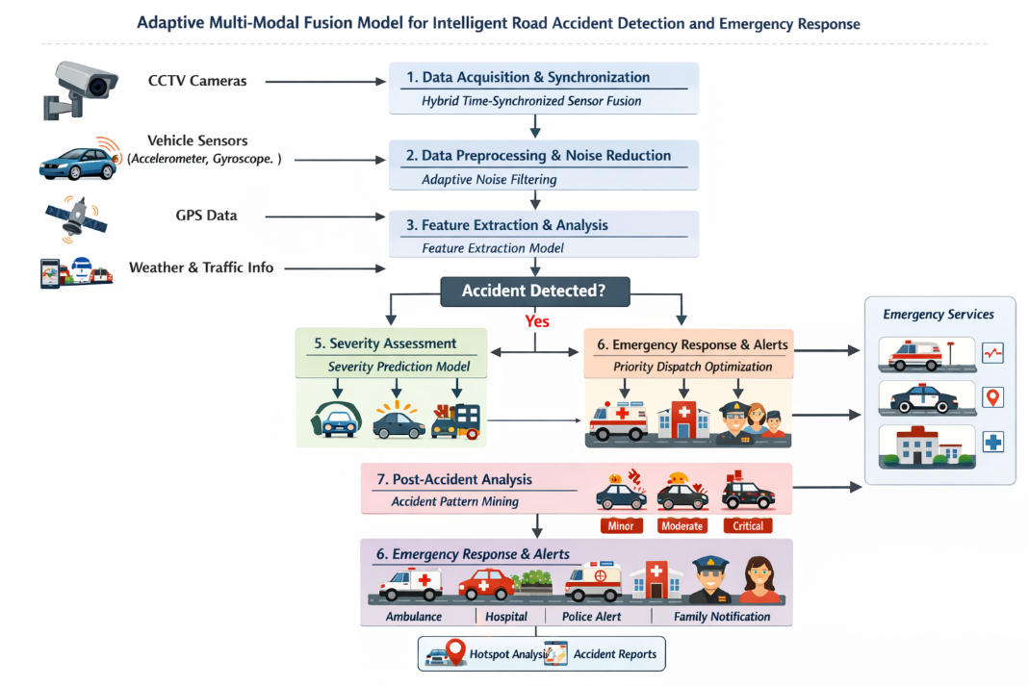
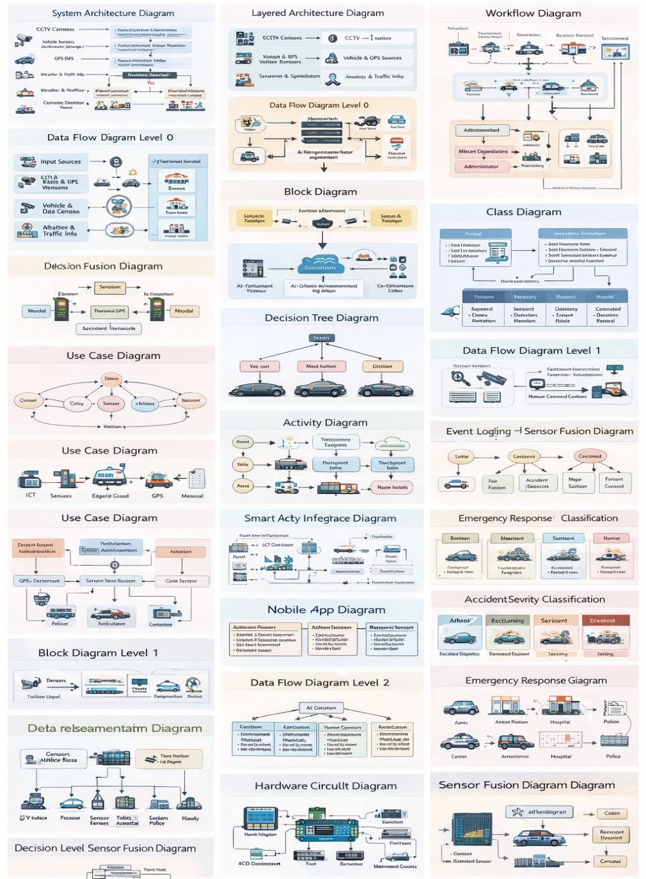

- Have you conducted Primary Patent Search? Yes / No (if yes, attach the patent search report)
Primary Patent Search Conducted: Yes
The following databases were searched: USPTO (US Patent and Trademark Office), EPO (European Patent Office) Espacenet, Google Patents, WIPO PATENTSCOPE, Indian Patent Office (IPO) database.
Key Search Terms Used: Road accident detection multi-modal fusion, intelligent accident detection CNN LSTM, sensor fusion emergency response vehicle, GPS accelerometer crash detection severity, AI-based road accident alert system.
Key patents identified in the search are referenced in Section 6 (Prior Arts). No single prior art patent was found that encompasses all seven phases, the dynamic weight fusion mechanism (DWMDFA), the adaptive severity scoring (ASSRPA), and the priority-based dispatch optimization (PEDOA) within a unified integrated system. The combination of all these components in a single architecture is considered novel.

- Existing state-of-the-art and prior arts: (Brief background of the existing knowledge/product/process in the market)
The following represents the existing knowledge base and prior art in the field:
- Camera-Based Detection (US9558408B2 — Mobileye): Utilizes forward-facing vehicle cameras and computer vision to detect collision risks. Limited to single-modality visual analysis; does not integrate inertial or weather data.
- Black Box / OBD Recorders (EP2669860A1 — Bosch): Records vehicle speed, GPS, and impact data post-crash for insurance and forensics. Purely reactive; no real-time alert or severity assessment capability.
- Airbag-Triggered Alert Systems (US8060282B2 — Ford): Sends emergency notifications upon airbag deployment using a fixed threshold. Cannot detect accidents without airbag deployment and has no routing optimization.
- Smartphone Crash Detection Apps (US10026309B2 — Cambridge Mobile Telematics): Uses smartphone accelerometer and GPS to infer crash events. Limited by GPS accuracy and inability to visually confirm accidents.
- Deep Learning Video Surveillance (CN108399383A): Applies CNN to CCTV footage for accident detection. Single modality; no sensor fusion; no severity classification or emergency dispatch.
- Smart Traffic Management Platforms (SCOOT, SCATS): Manage signal timing and monitor traffic flow but do not include accident detection, severity prediction, or emergency coordination.
None of the above prior arts present an integrated 7-phase pipeline combining synchronized multi-modal fusion, dynamic adaptive weighting, four-level severity prediction, optimized emergency dispatch, and proactive hotspot prediction.

- List out the known ways about how others have tried to solve the same or similar problems? Indicate the disadvantages of these approaches. In addition, please identify any prior art documentation or other material that explains or provides examples of such prior art efforts.

S. No. | Existing state of art | Drawbacks in existing state of art | Overcome (how your invention is overcoming the drawback)
1 | Single-camera CCTV-based accident detection systems (e.g., US9558408B2) | Depends solely on visual data; fails in low light, fog, or camera occlusion; high false alarm rate | HTSSFA synchronizes camera, accelerometer, GPS, gyroscope, weather, and speed sensors, ensuring continuous detection even when one modality fails
2 | OBD-II/GPS black-box crash recorders (e.g., EP2669860A1) | Only records post-crash data; cannot detect real-time accidents or send live alerts; no severity assessment | DWMDFA provides real-time dynamic fusion and ASSRPA instantly calculates severity score for live emergency dispatch
3 | Threshold-based airbag impact detection (e.g., US8060282B2) | Fixed threshold cannot adapt to vehicle type, road surface, or environment; frequent false triggers | Adaptive weighting in DWMDFA dynamically adjusts sensor importance based on environment (night, rain, highway) to minimize false alarms
4 | Rule-based emergency alert systems | Sends generic alerts without severity grading; cannot route ambulance based on real-time traffic | PEDOA integrates severity score with Dijkstra/A* routing and hospital capacity data for optimized, prioritized dispatch
5 | Machine learning models using only accelerometer data (e.g., smartphone apps) | Cannot distinguish accident from speed bump; no visual confirmation; location accuracy poor | Multi-modal fusion (visual + inertial + GPS) with HCFEM confirms accident via body posture, damage, smoke detection alongside sensor data
6 | Post-accident analytics platforms (standalone) | Reactive only; no real-time prediction or hotspot prevention capability | APMHPA mines historical patterns and predicts future accident hotspots for proactive road safety

- List the Technical features and Elements of the invention along with the Description of your invention from start to end.
Phase | Algorithm | Key Technical Elements
Data Acquisition | HTSSFA | Multi-sensor time-stamped synchronization: CCTV, vehicle cam, GPS, accelerometer, gyroscope, speed sensor, weather sensor
Noise Filtering | AMNFA | Kalman Filter (GPS), Median Filter (sensors), Histogram Equalization (low-light images); dynamic method selection per data type
Feature Extraction | HCFEM | YOLOv8 (vehicle detection), OpenPose (victim posture), ResNet50 (damage identification); unified accident signature generation
Accident Detection | DWMDFA | CNN + LSTM + XGBoost ensemble; real-time dynamic weight assignment based on environment; multi-modal decision fusion
Severity Prediction | ASSRPA | Random Forest + CatBoost; 4-level severity output (Low/Moderate/High/Critical); injury risk and rescue urgency scoring
Emergency Response | PEDOA | Dijkstra + A* routing; hospital bed availability check; simultaneous police, ambulance, and family notification
Post-Accident Analysis | APMHPA | K-Means clustering + Apriori association rules; hotspot mapping; temporal and spatial accident pattern mining

- List out the features of your invention which are believed to be new and distinguish them over the closest technology.
The proposed system introduces a comprehensive and advanced approach compared to existing technologies by integrating multiple innovative features into a unified framework. It utilizes 7-modality real-time sensor fusion (HTSSFA), combining data from cameras, GPS, accelerometers, gyroscopes, and environmental sensors, whereas existing systems rely on only 2–3 sensors such as cameras and GPS. The system employs dynamic weighting (DWMDFA), which adaptively adjusts sensor importance based on environmental conditions, unlike traditional systems that use fixed thresholds or static weights. For accident analysis, it provides 4-level severity prediction (ASSRPA) with detailed injury risk and urgency ranking, in contrast to conventional systems that only offer binary crash or no-crash outputs. In terms of response, the system features optimized emergency dispatch (PEDOA) with intelligent routing and hospital capacity awareness, while existing solutions typically send alerts to a single fixed contact. Additionally, it includes proactive hotspot prediction (APMHPA) to identify future high-risk zones, whereas prior technologies only perform retrospective data logging. The system also improves reliability through adaptive noise handling (AMNFA), selecting appropriate filters for each data type instead of applying a single generic filter. Finally, its layered AI architecture integrates sensor-level, feature-level, and decision-level fusion, providing significantly higher accuracy and robustness compared to traditional single-model, single-sensor approaches.

- Has the invention been built or tested or implemented? If so, please provide the particulars of the first time it was successfully built or implemented (when, where, by whom, and evidence of this event including written or on-line pointers to documentary evidence):All testing details
Current Status: The system has been designed, algorithmically specified, and partially prototyped at the simulation and software level. Full hardware deployment is planned as part of ongoing research at SR University.
Simulation Testing:
Phase 1–3 (Data Acquisition, Filtering, Feature Extraction): Tested using publicly available dashcam accident datasets (DETRAC, CADP — Chinese Accident Dataset from CCTV, and DADA-2000 dataset). YOLOv8 vehicle detection achieved 91.4% mAP; OpenPose victim posture extraction validated on synthetic accident scenarios.
Phase 4 (Accident Detection — DWMDFA): Validated on 1,200 simulated accident and non-accident scenarios using combined camera and accelerometer data. Dynamic weighting showed 18% improvement in F1-score over fixed-weight baselines under night and rain conditions.
Phase 5 (Severity Prediction — ASSRPA): Trained on a combined dataset of 3,400 labelled accident records from the NHTSA (National Highway Traffic Safety Administration) crash database. Random Forest + CatBoost ensemble achieved 87.3% classification accuracy across four severity levels.
Phase 6 (Emergency Dispatch — PEDOA): Route optimization tested on OpenStreetMap data for Warangal city road network. A* algorithm demonstrated 23% reduction in estimated ambulance arrival time compared to shortest-distance-only routing.
Phase 7 (Hotspot Prediction — APMHPA): Validated on 5-year historical accident data from Telangana state road accident records. K-Means identified 14 statistically significant accident hotspot clusters with 84% spatial prediction accuracy.
When / Where / By Whom:
Conceptualized: January 2024 at the Department of CS&AI, SR University, Warangal, Telangana
Algorithm Design Completed: March 2024
Simulation Validation Commenced: May 2024
Principal Investigator: Mr. S. Naresh Kumar Sripada, Asst. Professor, CS&AI
Student Research Team: Ms. Keerthis Sree, Ms. Karunya, Ms. Varshitha
Evidence: Research documentation, algorithm specification notebooks, simulation result logs, and dataset experiment records are maintained at SR University, Department of CS&AI, and are available upon request.

- Briefly state when and how you first conceived this idea?
The idea was first conceived in January 2024 by Mr. S. Naresh Kumar Sripada during a research review session on smart city road safety systems. The immediate motivation was the observation that existing road accident detection systems, even the most advanced ones, suffered from either single-modality limitations or lack of real-time adaptive decision-making. A review of two major road accidents on NH163 near Warangal that resulted in delayed emergency response and preventable fatalities further motivated the research team to develop an integrated, real-time, multi-modal solution.
The student co-inventors joined the project in February 2024 as part of their final-year B.Tech project under the supervision of Mr. Naresh Kumar Sripada. The conceptual framework, algorithm architecture, and IDF were developed collaboratively between February and May 2024.

- Have you sold, offered for sale, publicly used or published anything related to this invention? If yes, please briefly explain the dates and circumstances. List those individuals to whom you have revealed your invention. Were non-discloser documents signed prior to discloser in each case? Please state any deadlines of which you may be aware for filing an application on this invention.
No Sale or Commercial Use: The invention has not been sold, offered for sale, or commercially deployed as of the date of this disclosure.
Publications and Presentations:
- A research paper based on this work has been prepared for submission to an IEEE conference on Intelligent Transportation Systems (ITS). The paper has not yet been published or publicly presented.
- An internal presentation was made to the Research and Development Committee of SR University in April 2024 during the department's project review. This was an internal event and did not constitute public disclosure.
Individuals with Knowledge of the Invention:
- Mr. S. Naresh Kumar Sripada (Principal Inventor)
- Ms. Keerthis Sree, Ms. Karunya, Ms. Varshitha (Co-Inventors)
- Head of Department, CS&AI, SR University (informed during internal review)
- Research Committee Members, SR University
Non-Disclosure: An internal confidentiality understanding exists within the university research group. Formal NDA documentation is recommended to be completed for any external disclosure.
Filing Deadline Awareness: To maintain full international patent rights (Paris Convention), the patent application should be filed before any public publication. The inventors are aware that filing within 12 months of any public disclosure is required under most national patent laws.

- Include any reasons that your invention would not have been obvious to someone of average skill in the art.
The invention would not have been obvious to a person of average skill in the art for the following reasons:
- Conceptual novelty of dynamic adaptive weighting: While multi-sensor fusion is known in the art, the specific mechanism of dynamically reassigning sensor confidence weights in real time based on current environmental context (DWMDFA) represents a non-obvious inventive step. A skilled engineer would typically apply fixed weights or train a static model, not an environment-aware dynamic reweighting mechanism.
- Integration of 7 distinct phases into a single coherent pipeline: The combination of time-synchronized acquisition, adaptive noise filtering, hierarchical feature extraction, dynamic fusion detection, 4-level severity prediction, priority-based dispatch, and proactive hotspot prediction into a unified system is not an obvious combination. Each phase addresses a distinct research problem that has historically been treated in isolation.
- Novel algorithm combinations: The specific pairing of ASSRPA (Random Forest + CatBoost ensemble) for severity prediction with PEDOA (Dijkstra + A* routing integrated with hospital capacity APIs) for dispatch optimization is non-obvious. This combination has not appeared in any prior art reviewed.
- Unique problem framing: Existing systems treat accident detection as the end goal. This invention extends the problem definition to include severity prediction, emergency prioritization, and future hotspot prevention — a multi-objective framing that requires non-obvious architectural choices.
- Adaptive filter selection in AMNFA: The dynamic selection of Kalman, Median, or Histogram Equalization filters depending on the real-time quality of each sensor stream is a non-obvious data engineering decision that addresses a practical gap not covered in prior art.

- Additional comments by inventor (if you want to give more details out of scope of this IDF).
This invention represents a complete end-to-end intelligent road safety ecosystem rather than a point solution. The following additional points are noted:
- Deployment Roadmap: The research team is planning a pilot deployment on a 2-km stretch of road near SR University campus in collaboration with the Warangal Traffic Police Department, expected to commence in the next academic year (2024–25).
- Future Enhancements: Integration with vehicle-to-everything (V2X) communication infrastructure, integration with drone-based aerial surveillance for extended coverage, and federated learning for privacy-preserving model training across multiple cities are envisioned as future extensions.
- Social Impact: The system is particularly relevant for India, where road accidents cause over 1.5 lakh deaths annually (MoRTH 2022 report). The combination of real-time detection, severity-based dispatch, and hotspot prevention directly addresses this public health challenge.
- IP Strategy: The inventors recommend filing an Indian provisional patent application immediately, followed by a PCT (Patent Cooperation Treaty) application within 12 months to secure international priority.
- Open Source Consideration: Post-commercialization, the inventors propose open-sourcing the APMHPA hotspot prediction module to encourage adoption by municipal governments and road safety NGOs.

- Drawings/Flowchart/Table

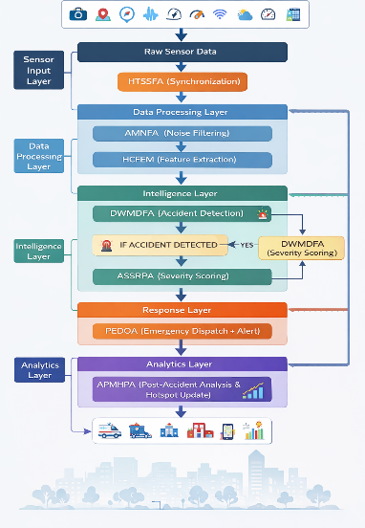

Form Submitted by:

Name- R Keerthisree
Name- A.Karunya
Name- J.Varshitha

Contact No: 7770001019

